Kurt Jastin Fabria

Insert:

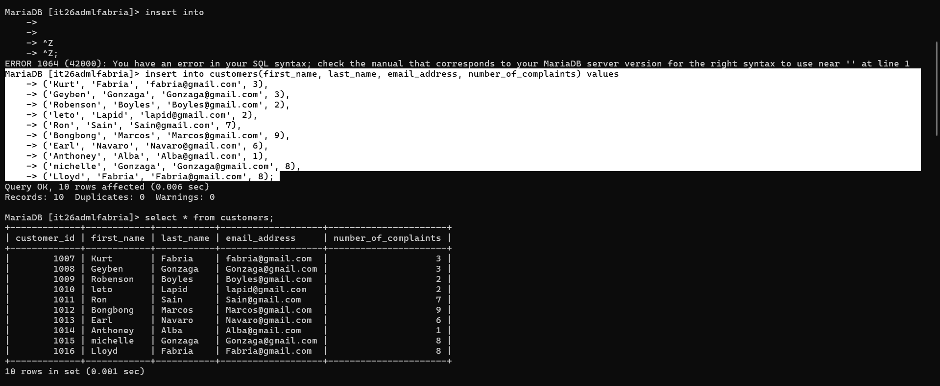

Select:

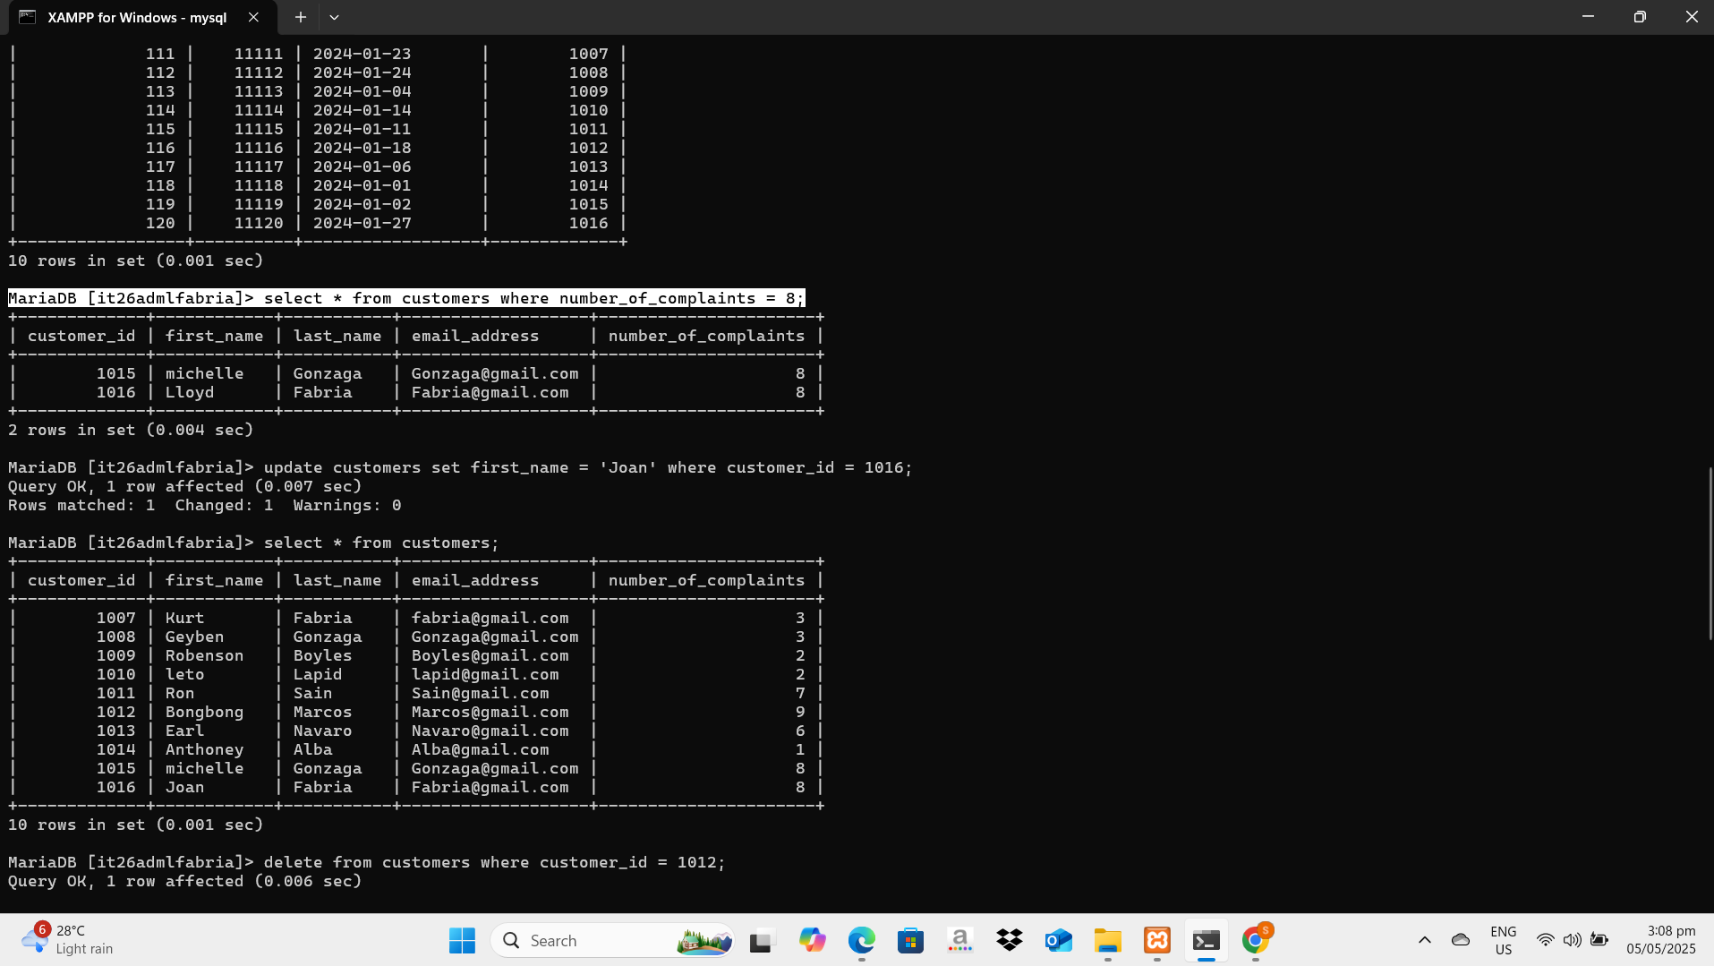

Update:

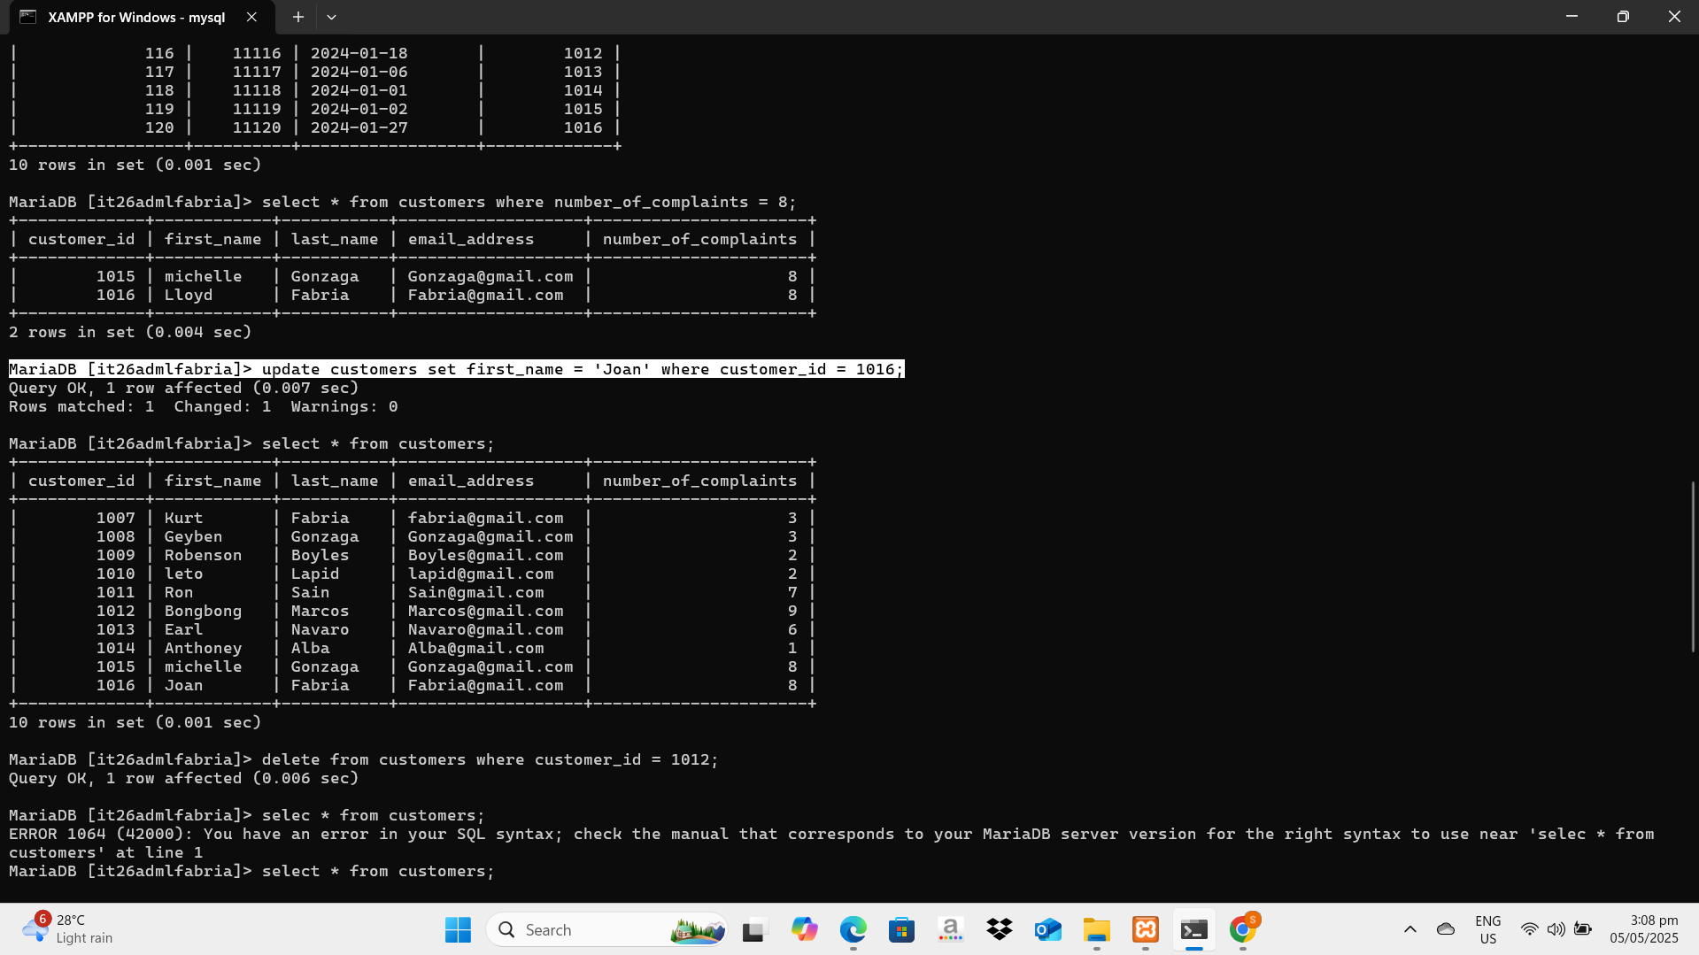

Delete:

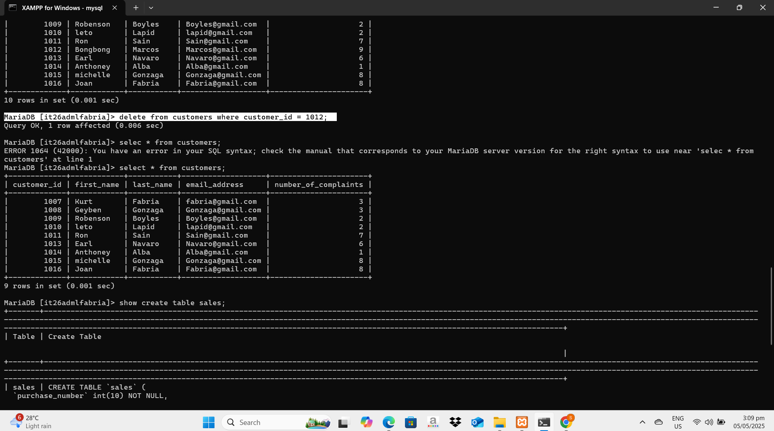

Cascade:

Ma’am, I haven’t performed a cascading command because in your sql file, the cascade(delete/update) are already set.

